**Executive Summary**

Apple is a company that is large in scale, profitable and has healthy cash flow, which may help it succeed during a recession (Klebnikov, 2022). This report found Apple has growth potential, competitive advantages, strong fundamentals, great corporate governance, and sustainable earnings. The latest price is undervalued and fair to buy. Apple’s pricing power comes from its products and ecosystem. IOS users have to live with the IOS ecosystem, e.g., the App Store almost has a monopolistic-like status, and Apple services are nearly necessities to those who own its devices due to the lock-in relation. Also, studies indicate Apple products shall increase productivity, which offsets the price change (Parnell, 2021). Economically, the pricing power allows Apple to raise prices without affecting demand much (Jasinski, 2022).

As PEST analysis in Appendix 1, politically, the Chinese zero covid lockdown triggers global supply chain issues, while the Russia-Ukraine war leads to unstable energy supply. Both fuel the already skyrocketing inflation and stimulate the Fed to raise interest rates, which is unfavorable to the stock market. In the short run, the demand for consumer electronics is projected to decline due to excessive consumption during the pandemic (Port, 2022). In the long term, tech giants are investing heavily in the Metaverse, which could be a singularity for innovation and revenue growth. As SWOT analysis in Appendix 2, other than strength in design, R&D, and supply chain management, Apple has the No1. Brand premium, appealing profitability, and consumer retention rates (AppleInsider). Apple has opportunities in AR/VR devices, AI tech, and a growing user base. Remarkably, the hardware leasing model and service-oriented strategy are refreshing its business model. However, Apple products are expensive, and the sales have declined (Gewirtz, 2020). The company also faces threats from competition, anti-monopoly legislation, and black swan events. Overall, the good ones outweigh the bad.

Here we will use three methods to measure Apple’s competitive advantage. First would be Porter's Five Forces analysis. Apple’s threat of new entry is low, due to the high capital requirement in R&D and the brand development. The threat of substitution is low. Although its competitors are strong, Apple has a high customer lock-in. Therefore, the buyers’ power is low. Customers have high brand loyalty in the Apple ecosystem and the products share iCloud contents. Moreover, Apple had no single customer accounting for more than 10% of net sales in 2018 to 2020 (Apple Inc.10-K, 2022). This means individual customers do not have power to reduce prices or to affect Apple. The suppliers’ power is also low because Apple can access many suppliers around the world. Overall, the firm has a high competitive advantage based on five forces. Economic profit would be the second measurement. Apple’s ROIC is 35.38% and WACC is 10.04%, so the economic profit is 25.34% Today (Gurufocus). As shown in Appendix 3 and 4, in the consumer electronics industry, Apple has one of the highest economic profit, and stable revenue growth. According to Appendix 5, the PE ratio for Apple, in comparison, is not cheap, but it is reasonable. Over the past five years, Apple has increased economic profit, one of the reasons is that Apple is shifting to a service-oriented strategy to explore new markets (Evans, 2021). We expect the economic profit to continue to expand.

For the pricing and cost advantages, Apple is consistently innovative and has a total of 72054 patents globally (Insights, 2022). Apple has great quality in great in-store service, control of software and hardware, game-changing tech and high security. It has a high level of customer Lock-in and is a well-known brand. The firm has innovative inventory management and low inventory turnover, because it cuts down on warehouses and makes suppliers compete between themselves (Lu, 2022). The ecosystem and the related developers, programmers, designers are its unique resources. The scalable products also raise the customers' attention to buy more from apple. Last year in April, Apple released an update called “App Tracking Transparency” for iPhones to limite apps' ability to track user behavior. The policy challenges Big Tech platforms like Snap, Facebook and Youtube who lost $10 billion Ads revenues (Read, 2021). In contrast, it benefited Apple’s advertising. Apple’s services revenue including ads and subscription, grew 24% year over year last quarter, [according](https://www.apple.com/newsroom/2022/01/apple-reports-first-quarter-results/) to its earnings report (Goetzen, 2022).

Apple's Board of Directors oversees the Chief Executive Officer and other senior management. There are three independent committees which are Audit Committee, Compensation Committee and Nominating Committee. Apple has a strong leadership profile. The head of the nominating committee is the former Vice President of the United States, and its Nominating Committee Chair Susan Wagner is the co-founder and director of Blackrock (Apple, 2022). Apple’s leadership profile demonstrates its deep connection with private equity, technology, and politics, which is also a boost for inventors’ confidence.

In 2021, Apple reported a record high of net sales, which increased by 33% from a year earlier. All categories of products experienced growth in sales driven by the launch of new models including iPhone SE and iPad Air. (Apple, 2022). However, we notice that Apple’s business model is shifting from product to service as the proportion of revenue from service shows a trend of increase since 2019.The company keeps developing features to capture the trend in the competitive environment. For example, the new apple watch has more features to health data, a feature that targets the younger generation who pursue a healthy lifestyle while iCloud embedded features designed for working remotely. Third, the company is invested in home essentials such as Apple TV+. Besides, the company also plans to shift its major hardware to leasing service by the end of 2022, which makes owning a phone like subscribing to apps (Minter, 2022). Historical data shows that people on average purchase a new iPhone every three years, but the leasing service will make them keep paying the company monthly and increase the retention rate to further enhance customer loyalty to Apple’s other services such as Apple TV and Apple Music (Minter, 2022).

In addition, the company is effective at its supply chain management. Historical data indicates that Apple can diversify its product without adding pressure to its supply chains. From 2018 to 2021, the company has launched a variety of new products including Air pods, Mac studio and iMac. Apple’s Inventory Turnover still decreased by 25% in 4 years. In addition, Apple has a cash conversion cycle of -60.13 days. This indicates the company has a strong bargaining power with its suppliers. This bargaining power is especially important during inflation because it helps the company to absorb the rising cost to avoid the squeeze in margin.

For valuation, both EBITDA and PE Multiples Valuation from Appendix 6 estimate Apple’s stock price to be worth over 200 USD per share, which is above the current price. The perpetuity growth method indicates the stock price is overvalued. Given the high-growth expectation of Apple, the former estimates are deemed to be more appropriate to use.

Apple’s earnings in 2021 are the best on record. Nonetheless, it is driven by the reliance on digital devices during the pandemic. As Appendix 7 indicates, others from the same industry benefit from the pandemic too. In the short run, as the pandemic ends, and CTA expects lower demand, Apple’s earnings in 2021 are not sustainable. In the long run, the earnings trend has been stable over the past decade. The competitive advantages, innovative products, and new business models shall keep the earnings high. Apple transforms into a service company shall avoid the competition and market saturation by exploiting the possibilities of the ecosystem.

Apple doesn’t rely on a single entrepreneur or blockbuster but on its ecosystem, the integration of hardware and software, and the lock-in relation. Apple has been careful about the M&As, all of which are small and designated to supplement the ecosystem. Apple has been consistently mindful of its social responsibility. Apple is innovative, and its strong “moat” shall fend off imitators. All of these make Apple unique, sustainable, and unlikely to fall into the well-known traps, e.g. entrepreneurship failure, management failure, social failure, and total failure.

In sum, Apple is in a “virtuous cycle” with sustainability, competitive advantages, great leadership, appealing fundamentals, and a reasonable current price. Despite the supply chain issue remaining pressing, it should improve early this year according to Tim Cook. Overall, the positive side outweighs the downsides. This report found Apple an investment opportunity.

**Appendix**

Appendix 1: PEST Analysis

|  |  |
| --- | --- |
| Political | Factor1: China zero covid lockdown triggers global supply chain issues, e.g. chip shortage, fueling inflation.  Factor2: Russia-Ukraine war leads to unstable energy supply, raising commodity price and inflation. |
| Economic | Factor3: FED plans on tapering and increasing interest rate, but it will take time to curb inflation. |
| Social | Factor4: Consumer-Tech overall may decline in 2022 due to excessive consumption during Covid-19 lockdown period. |
| Technological | Factor5: Tech giants are betting on the metaverse. Potential singularity for innovation and revenue growth. |

Appendix 2: SWOT Analysis

|  |  |
| --- | --- |
| Strength | 1. Brand premium - ranked 1st in Brand Finance Global 500 2. Supply chain management - strong bargaining power on COGS 3. High profit margin - continued to grow YoY since 2019 4. Proficient research in tech innovation 5. Quality Design 6. Consumer Retention |
| Weakness | 1. Expensive products - target high income clients, not affordable to all 2. Declined sales in China - market share took over by local brands 3. Iphone unit sales kept declining 4. Incompatible with many software - IOS ecosystem is “closed end” 5. Slow innovation - Overreliance on iPhone, iPad, Mac, App Store, etc. |
| Opportunities | 1. New products, e.g. AR/VR headsets 2. Growing consumer base 3. Use AI tech to improve products’ capabilities 4. New leasing model 5. More service - collect utilities |
| Threats | 1. Supply chain disruption, chip shortage, etc. 2. Recession or Covid induced declined consumption, i.e. PEST Factor4 3. Competition from Samsung, Huawei, Xiaomi, Dell 4. Anti-monopoly lawsuits, regulations, and legislations 5. Black Swan events |

Appendix 3: APPLE 5-year Economic Profit

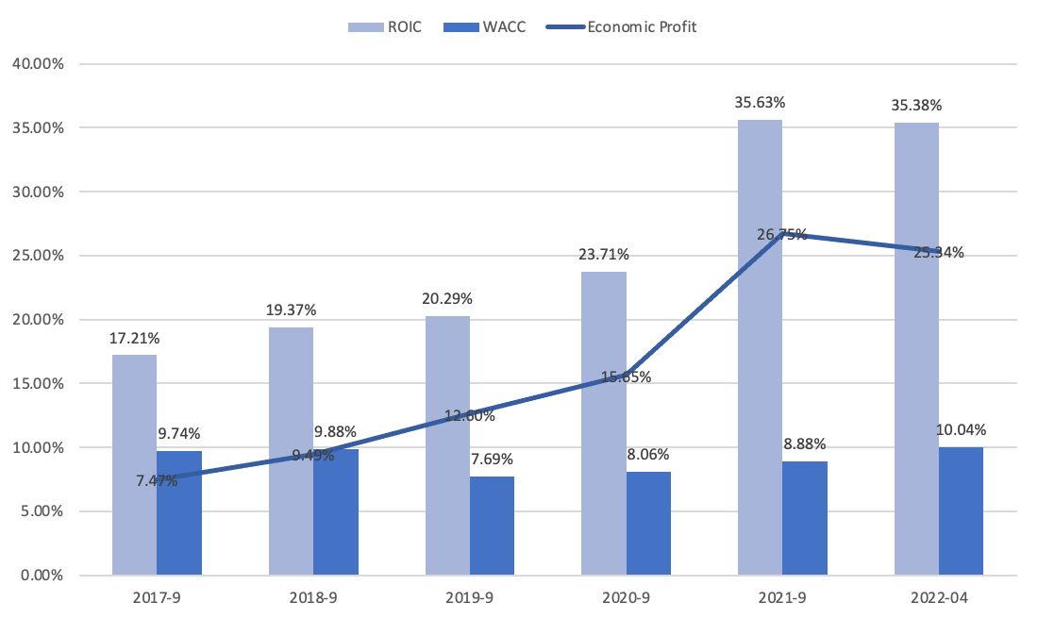

Appendix 4: APPLE & Competitors 5-year Economic Profit

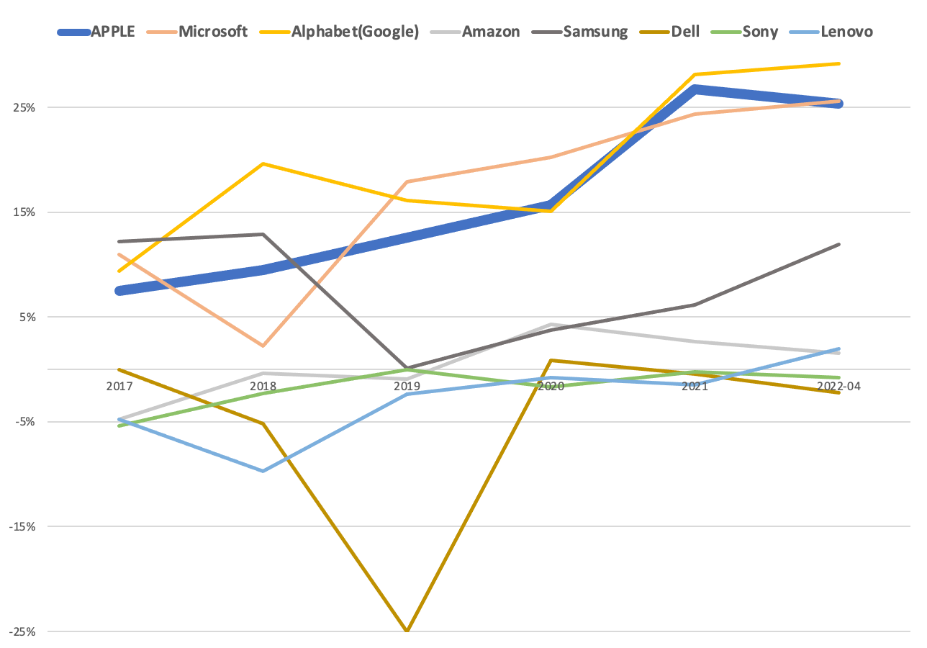

Appendix 5: APPLE & Competitors Analysis

|  |  |  |  |  |  |  |
| --- | --- | --- | --- | --- | --- | --- |
| **Company** | **ROIC** | **WACC** | **Economic Profit** | **3-yr Average Revenue growth** | **10-yr Average annual Total Return** | **PE Ratio** |
| **Apple** | 35.38% | 10.04% | 25.34% | 13.75% | 22.62% | 28.26 |
| **Microsoft** | 33.48% | 7.73% | 25.75% | 15.98% | 25.79% | 30.63 |
| **Alphabet(Google)** | 35.67% | 8.65% | 27.02% | 23.46% | 17.31% | 23.22 |
| **Amazon** | 9.33% | 7.66% | 1.67% | 26.33% | 32.02% | 48 |
| **Samsung** | 12.94% | 6.56% | 6.38% | 4.64% | 10.57% | 11.55 |
| **Dell** | 3.95% | 6.10% | -2.15% | 3.76% | 19.71% | 5.55 |
| **Sony** | 3.19% | 4% | -0.81% | 5.18% | 17.40% | 16.42 |
| **Lenovo** | 8.25% | 6.26% | 1.99% | 12.18% | 2.75% | 8.1 |

Appendix 6: APPLE Valuation

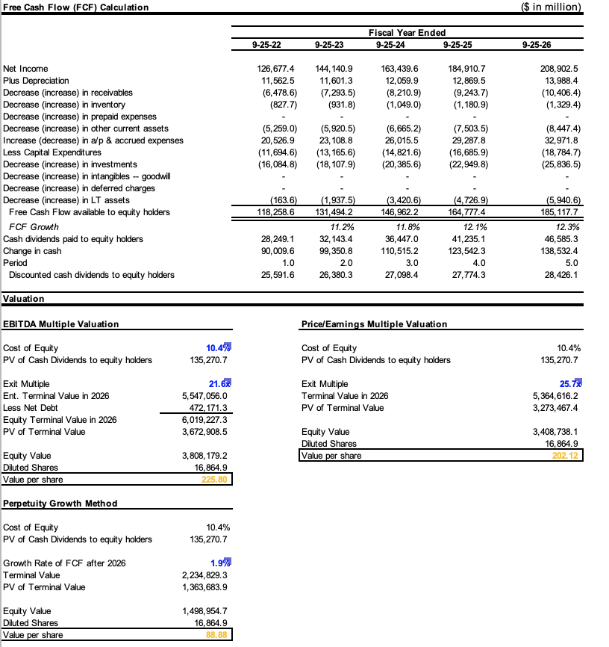

Appendix 7: NI

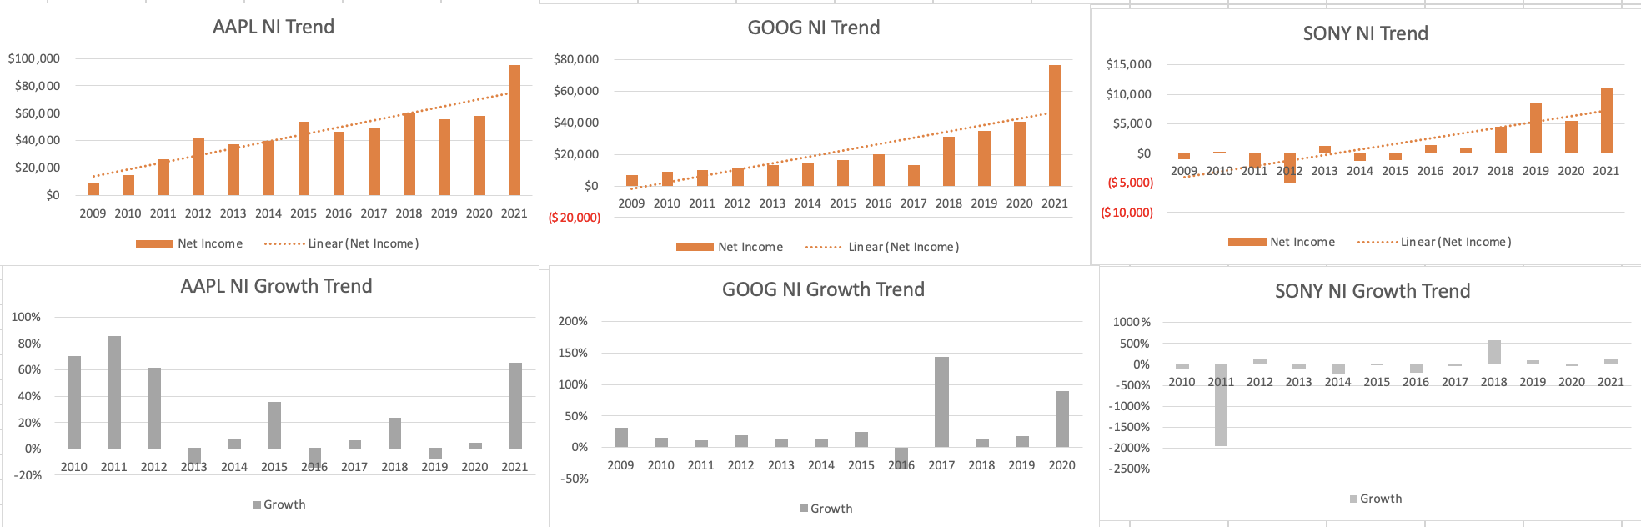

**Reference**

*Leadership and governance*. Apple. Retrieved April 28, 2022, from https://investor.apple.com/leadership-and-governance/default.aspx

*Apple Inc. Form 10-K For the Fiscal Year Ended September 28, 2019 TABLE OF CONTENTS*. Document. Retrieved April 28, 2022, from https://www.sec.gov/Archives/edgar/data/320193/000032019319000119/a10-k20199282019.htm

*Gurufocus.* Value Investing | Market Insight of Investment Gurus. Retrieved April 28, 2022, from https://www.gurufocus.com/

Evans, A. H. B. J., & Evans, J. (2021, December 21). *What Apple's approach to building services income tells us*. Computerworld. Retrieved April 28, 2022, from https://www.computerworld.com/article/3645372/what-apples-approach-to-building-services-income-tells-us.html

*Apple patents - key insights and stats*. Insights;Gate by GreyB. (2022, April 21). Retrieved April 28, 2022, from https://insights.greyb.com/apple-patents/

Lu, C. *Apple supply chain - the best supply chain in the world*. Inventory Management Software. Retrieved April 28, 2022, from https://www.tradegecko.com/blog/supply-chain-management/apple-the-best-supply-chain-in-the-world#:~:text=Looking%20back%20at%20the%20last,as%20possible%20is%20very%20important

Goetzen, N. (2022, January 31). *Apple ad revenues skyrocket amid its privacy changes*. Insider Intelligence. Retrieved April 28, 2022, from https://www.emarketer.com/content/apple-ad-revenues-skyrocket-amid-its-privacy-changes

Read, D. P. N. min, & Scott Ikeda·November 9, 2021. (2021, November 5). *New Apple privacy policy has cost Big Tech platforms $10 billion in lost ad revenue*. CPO Magazine. Retrieved April 28, 2022, from https://www.cpomagazine.com/data-privacy/new-apple-privacy-policy-has-cost-big-tech-platforms-10-billion-in-lost-ad-revenue/

*Apple retains most-valuable brand Crown as tech boom continues and TikTok soars*. World Trademark Review. (n.d.). Retrieved April 28, 2022, from https://www.worldtrademarkreview.com/apple-retains-most-valuable-brand-crown-tech-boom-continues-and-tiktok-soars

Gewirtz, D. (2020, September 2). *Here's an interesting chart: Iphone unit sales have been declining steadily for 5 years*. ZDNet. Retrieved April 28, 2022, from https://www.zdnet.com/article/heres-an-interesting-chart-iphone-unit-sales-have-been-declining-steadily-for-five-years/

Jasinski, N. (2022, April 6). *The key to surviving inflation is 'pricing power.' these companies have it in spades.* McDonald's, Nvidia, and 25 Other Stocks That Won't Be Stopped by Inflation | Barron's. Retrieved April 28, 2022, from https://www.barrons.com/articles/stocks-built-for-inflation-51649202855

Klebnikov, S. (2022, April 14). *Most wall street experts now predict stagflation-here's what that means for investors and the U.S. economy*. Forbes. Retrieved April 28, 2022, from https://www.forbes.com/sites/sergeiklebnikov/2022/03/15/most-wall-street-experts-now-predict-stagflation-heres-what-that-means-for-investors-and-the-us-economy/?sh=2324a8d01400

Parnell, C. (2021, May 4). *Why is Apple associated with high business productivity?* HardSoft. Retrieved April 28, 2022, from https://www.hardsoftcomputers.co.uk/blog/apple/why-is-apple-associated-with-high-business-productivity/

AppleInsider. (2021, October 29). *Apple has most loyal smartphone customers in US, study finds*. AppleInsider. Retrieved April 28, 2022, from https://appleinsider.com/articles/21/10/29/apple-has-most-loyal-smartphone-customers-in-us-study-finds

*Port, W. (2022) US Consumer Technology Revenue Sales end 2021 up 9%, following double digit growth in 2020*. The NPD Group. (2022, March 14). Retrieved April 28, 2022, from https://www.npd.com/news/press-releases/2022/us-consumer-technology-revenue-sales-end-2021-up-9-following-double-digit-growth-in-2020/